**CVENT FAQs:**

**How Do I Access the CVENT Portal:**

The only way to initially gain access to the CVENT MTMP Fall 2024 portal is via the email invitation from me/CVENT. This email is sent to the Main Admin/CVENT Contact designated on your contract. Once the admin accesses this email, they will be directed to the MTMP Fall 2024 specific CVENT site. The Main Admin/CVENT Contact is the only person who can initially access the portal. Once they are in, they can always add an additional Admin to access it as well.

**I am trying to log into CVENT and it is asking me for an Event Code, what do I do?**

There is no Access/Event Code Needed. The only way to initially sign in to the portal is via the email invitation that is sent to the designated Main Admin/CVENT Contact on your contract. Once you log in through the email, you will be directed to the MTMP Fall 2024 specific CVENT site.

**I am on CVENT but I do not see the MTMP Fall 2024 show?**

If you are not seeing the Fall 2024 conference, make sure you select “Switch Events” at the top left side of the menu and select the Fall 2024 event.

**How to transfer/substitute a registration?**

1. The original registrant would have received a confirmation email with a confirmation code. That person can forward the admin his confirmation email and the admin must go in through the confirmation email to make the change.
2. At the bottom of the confirmation email there is a button that says: Modify Registration –select this.
3. The next page will ask for the confirmation number (from page 1) copy and paste it in the box.
4. On the next page, click the button that says “Transfer Registration.” Then add the new person’s name and email. They will now get a new confirmation email and code.

**What Exhibitor Profile information do I need to include in the company profile section? Where will this information be advertised?**

The information you fill in here will populate to the conference app, so please be sure to upload your logo, general company information and any social media. Your booth number is already there; this is how attendees will know where to find you in the Exhibit Hall. The “Tagline” it asks for is not mandatory. If your company has a tagline such as: “ABC, we mean business!” then add that; if not, do not worry about adding anything. To be clear, MTMP is not providing any details, it is your responsibility to do so. Be as thorough as possible so attendees can learn about your company.

**What Exhibitor Profile fields are not mandatory:**

There are a few fields on the form that do not apply to this conference. You should not add information for these 4 fields: **Virtual Booth Banner, Tax ID/VAT Number**, **Virtual Meeting URL**, **Virtual Host Key**

**How do I access and assign our free CVENT lead capture license?**

Every company receives **one free** Lead Capture license. Only one registered staff may download the lead capture license to their individual device. If you want all staff to have access to lead capture, we suggest you bring a communal device to be shared by all (ie an ipad); otherwise only the person who downloaded the license will have access on their individual device.

Please see screenshots below for instructions:

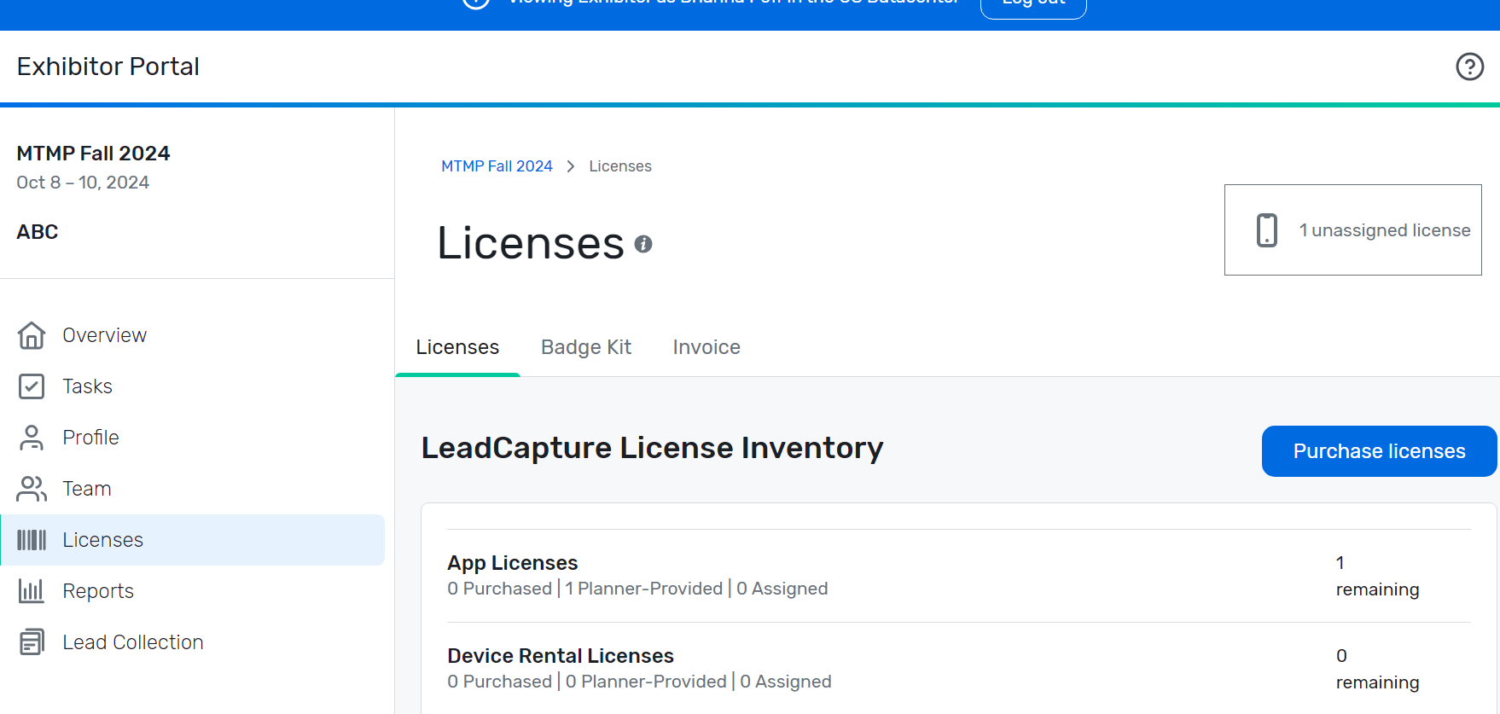

Select Licenses from the left-hand menu in your portal. The box shows you have 1 unassigned license. This page is where you will assign your free license to a registered staff member. Do not select “purchase license” and scroll down to License Assignments.

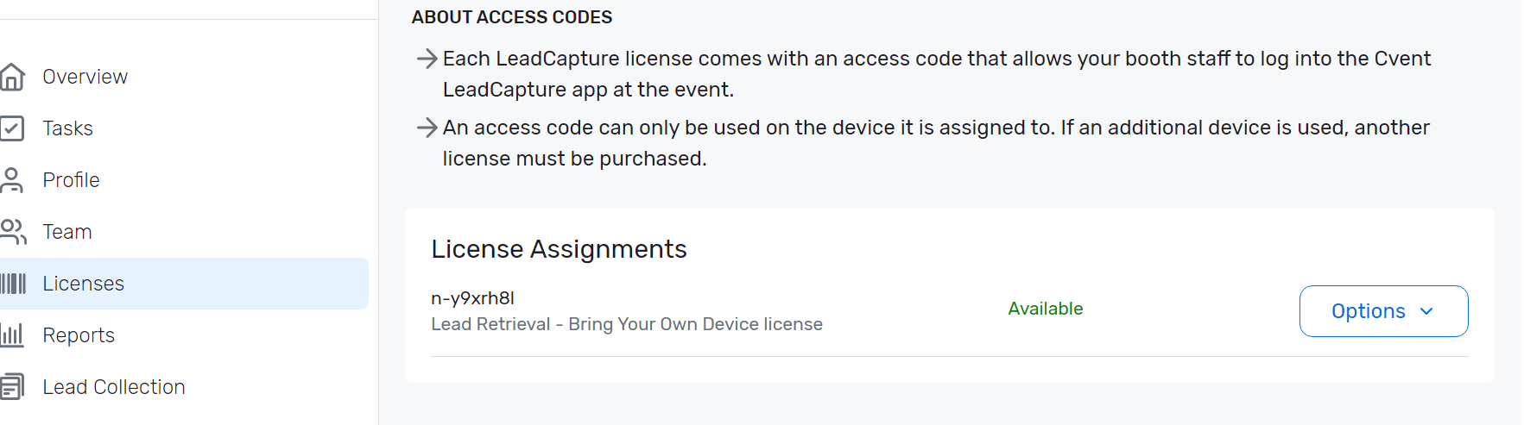

Next to License Agreements, select “Options”

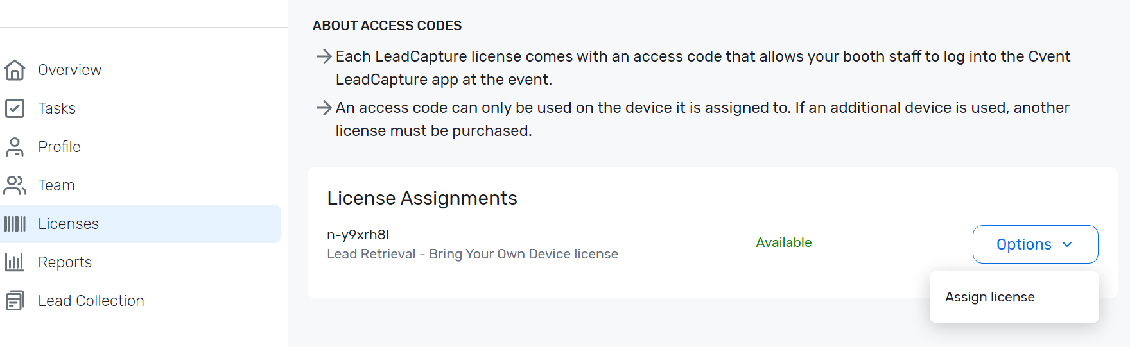

When you click Options, “Assign License” will appear. Select that option and assign your license to a registered Staff member. The license will be connected with their email and only one device. If you want all staff to have access to lead capture, we suggest you bring a communal device to be shared by all (ie an ipad).

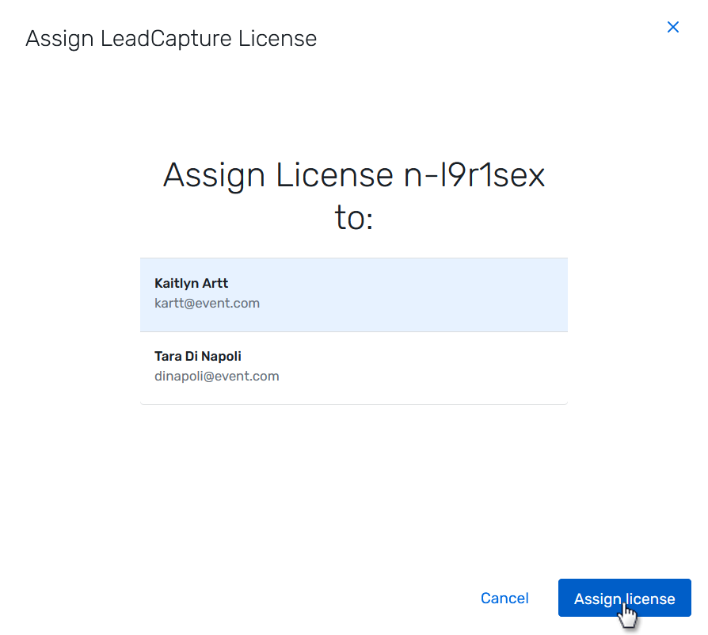

The staff you select to assign the license will automatically receive an email with their access code to log in to the LeadCapture app.

Please refer to the CVENT LeadCapture Information on our Exhibitor Kit for further details.

**None of these options have resolved my CVENT question or issue:**

**For additional questions or problems, please contact support through emailing leadcapture@cvent.com; or calling 866.318.4357 > Press 1 > 1 and then 6 for Exhibitor Support**