**CVENT LeadCapture Information:**

We are giving all of our vendors one FREE LeadCapture License so you can easily capture leads at the conference and run reports, etc. You can customize the system to ask questions pertinent to your company, and easily keep track of the contacts you meet. Every attendee badge will have a QR code containing their first name, last name, contact information, that you can easily scan.

Only one staff can sign in with their email to use this license and the license can only be downloaded to one device. You can use any of the approved devices listed below as long as they have a camera. If you would like everyone at your booth to have access to the license, we suggest bringing a communal device (ie an ipad) to download and sign in, so all staff can use. If you want additional licenses, you can purchase them in CVENT for $249+.

Please note we will have a LeadCapture Desk on site at MTMP to assist with any questions and to help you navigate this system.

**Aproved Devices for Lead Capture Licenses**

[The LeadCapture app](https://support.cvent.com/s/communityarticle/Scanning-LeadCapture-Leads) requires iOS 14.1 or higher. While LeadCapture is compatible with Android 8.0 or higher, it can only be downloaded on Android devices that have access to the [Google Play Store](http://play.google.com/store/apps/details?id=com.cvent.onarrival). The app is not available on Blackberry or Windows devices.

[How do I download LeadCapture for an Apple device? (cvent.com)](https://support.cvent.com/s/communityarticle/How-do-I-download-LeadCapture-for-an-Apple-device)

[How do I download LeadCapture for an Android device? (cvent.com)](https://support.cvent.com/s/communityarticle/How-do-I-download-LeadCapture-for-an-Android-device)

**How do I access and assign our free CVENT lead capture license?**

Every company receives **one free** LeadCapture license. Only one registered staff may download the lead capture license to their individual device. If you want all staff to have access to lead capture, we suggest you bring a communal device to be shared by all (ie an ipad); otherwise only the person who downloaded the license will have access on their individual device.

You can only assign a LeadCapture License to a registered staff member. If your staff is not registered, you cannot assign them a license.

Please see screenshots below for instructions to assign a license:

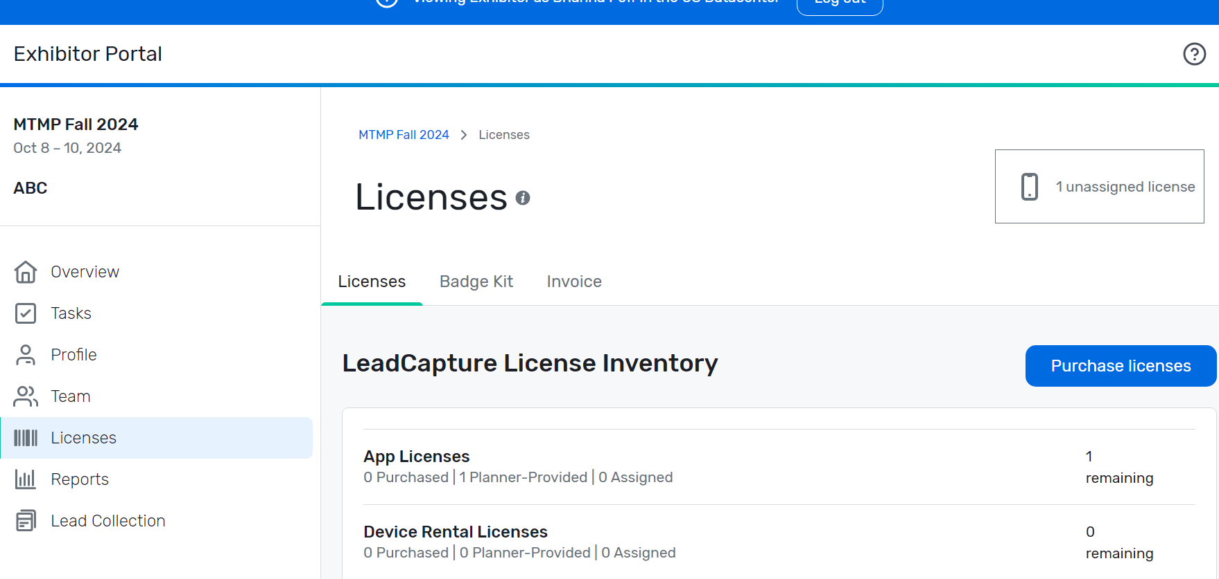

Select Licenses from the left-hand menu in your portal. The box on the right shows you have 1 unassigned license. This page is where you will assign your free license to a registered staff member. DO NOT select “purchase license” but instead, scroll down to License Assignments.

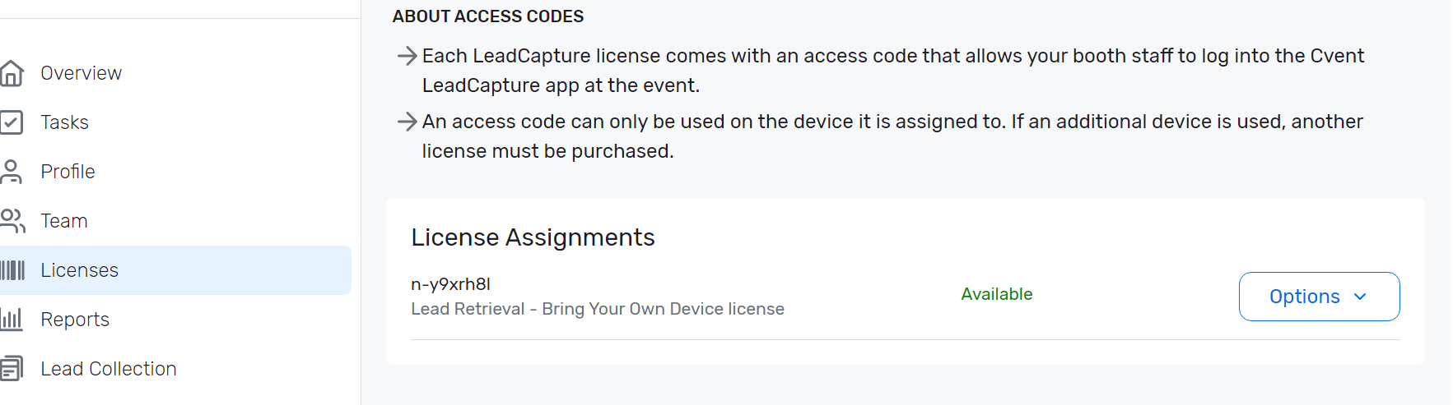

Next to License Agreements, select “Options”

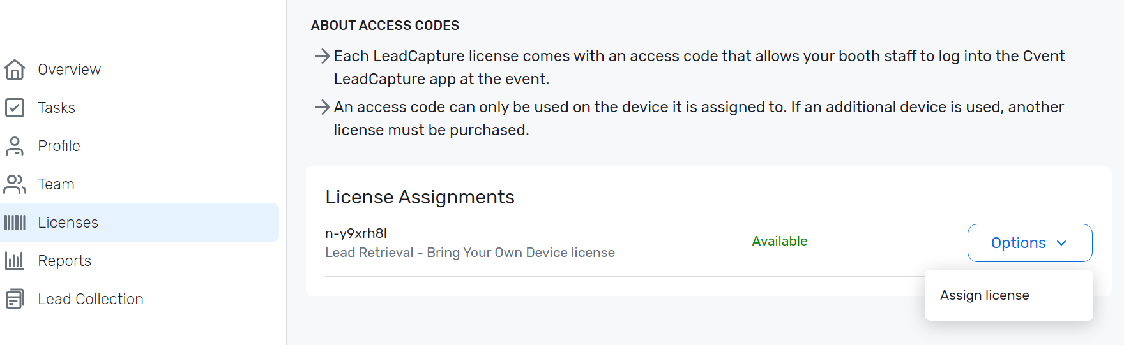

When you click Options, “Assign License” will appear. Select that option and assign your license to a registered Staff member. The license will be connected with their email and only one device. If you want all staff to have access to lead capture, we suggest you bring a communal device to be shared by all (ie an ipad).

|  |
| --- |
|  |

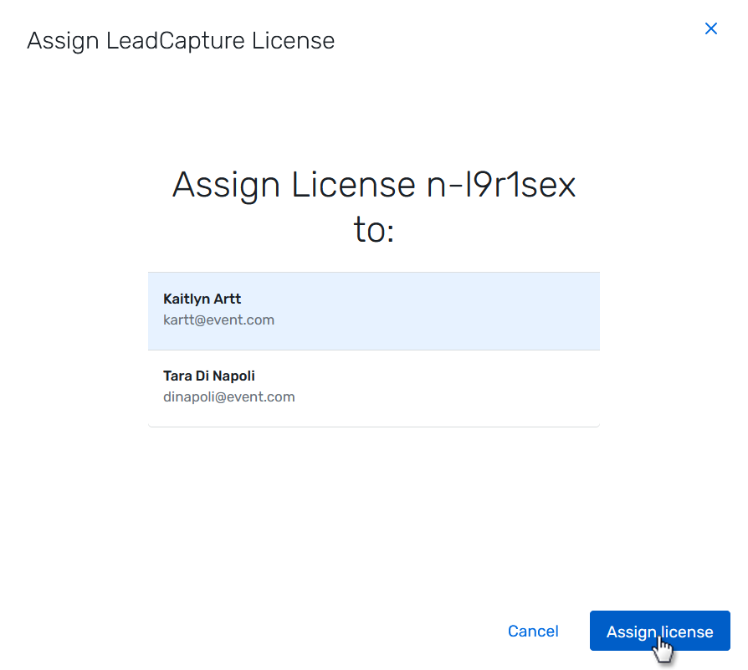

The staff you select to assign the license will automatically receive an email with their access code to log in to the LeadCapture app.

**How do I customize my Lead Capture Questions?**

From the left-hand mend, select Lead Collection. This is where you will see your current list of leads, you can customize your lead questions and adjust your lead capture settings.There are pre-set questions in there but you can add your own special questions/qualifiers as well.

For further information about how to scan leads and customize questions, please see this article: [Scanning LeadCapture Leads (cvent.com)](https://support.cvent.com/s/communityarticle/Scanning-LeadCapture-Leads)

**None of these options have resolved my CVENT question or issue:**

**For additional questions or problems, please contact support through emailing leadcapture@cvent.com; or calling 866.318.4357 > Press 1 > 1 and then 6 for Exhibitor Support**