The only way to initially gain access to the CVENT MTMP Fall 2025 portal is via the email invitation from me/CVENT. This email is sent to the Main Admin/CVENT Contact designated on your contract. Once the admin accesses this email, they will be directed to the MTMP Fall 2025 specific CVENT site. The Main Admin/CVENT Contact is the only person who can initially access the portal and register all of your staff. Once they are in, they can always add an additional Admin to access it as well.
For the examples shown below, we used an Exhibitor registration. If you are a Sponsor, your screen will reflect the Sponsor title instead.

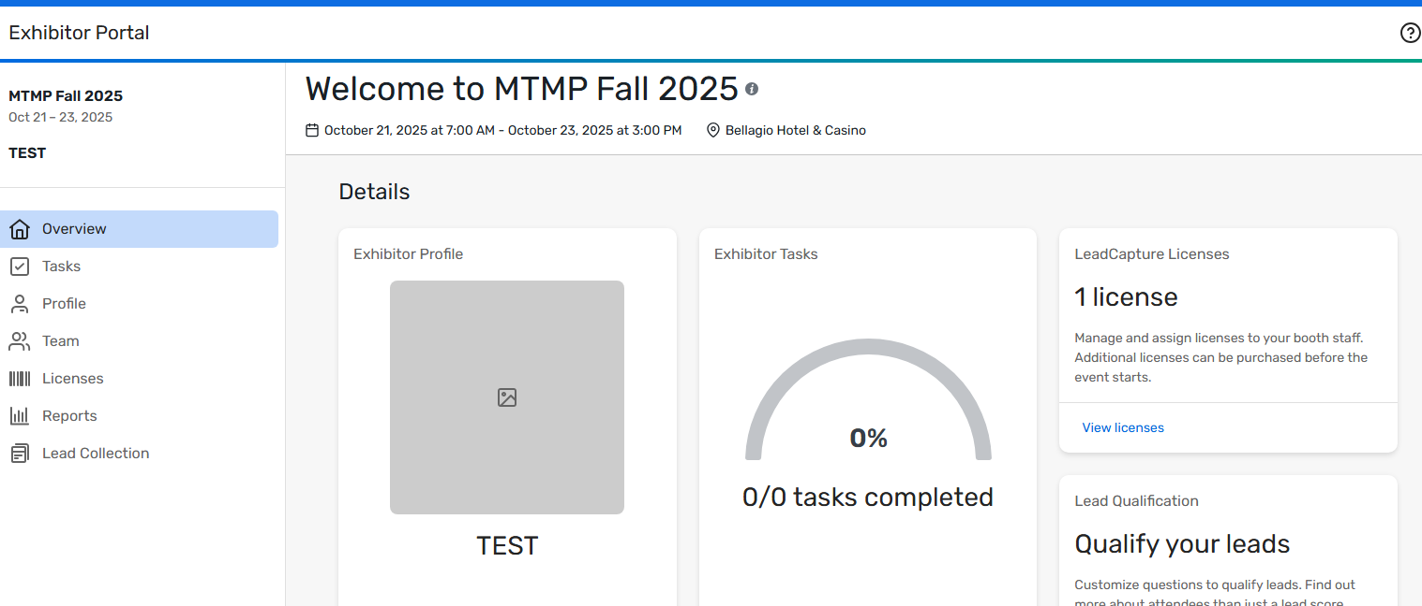
Home page view will show MTMP Fall 2025, dates and Bellagio hotel Exhibitor. If you are not seeing the Fall 2025 conference, make sure you select “Switch Events” at the top left side of the menu and select the Fall 2025 event.

There is no Access/Event Code Needed. If you are getting a message that references this, log out. You can only initially sign in to the portal via the email invitation that is sent to the designated Admin on your contract.

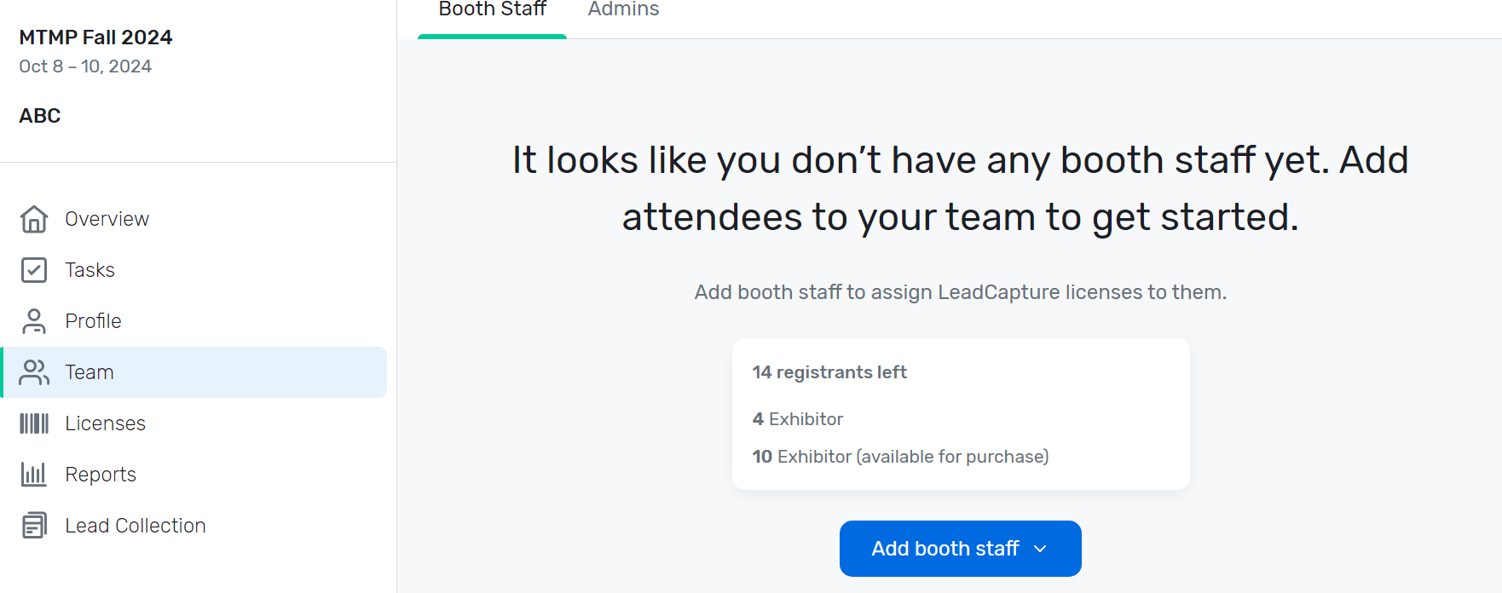

Select “Team” from left hand menu to register your staff. In this example, it shows the Exhibitor has 14 registrations left. PLEASE NOTE: the 4 Exhibitor count is what is included in your booth. The 10 Exhibitor (available for purchase) are 10 possible registrations available for purchase. They are not included.
Click the blue button “Add booth staff”.

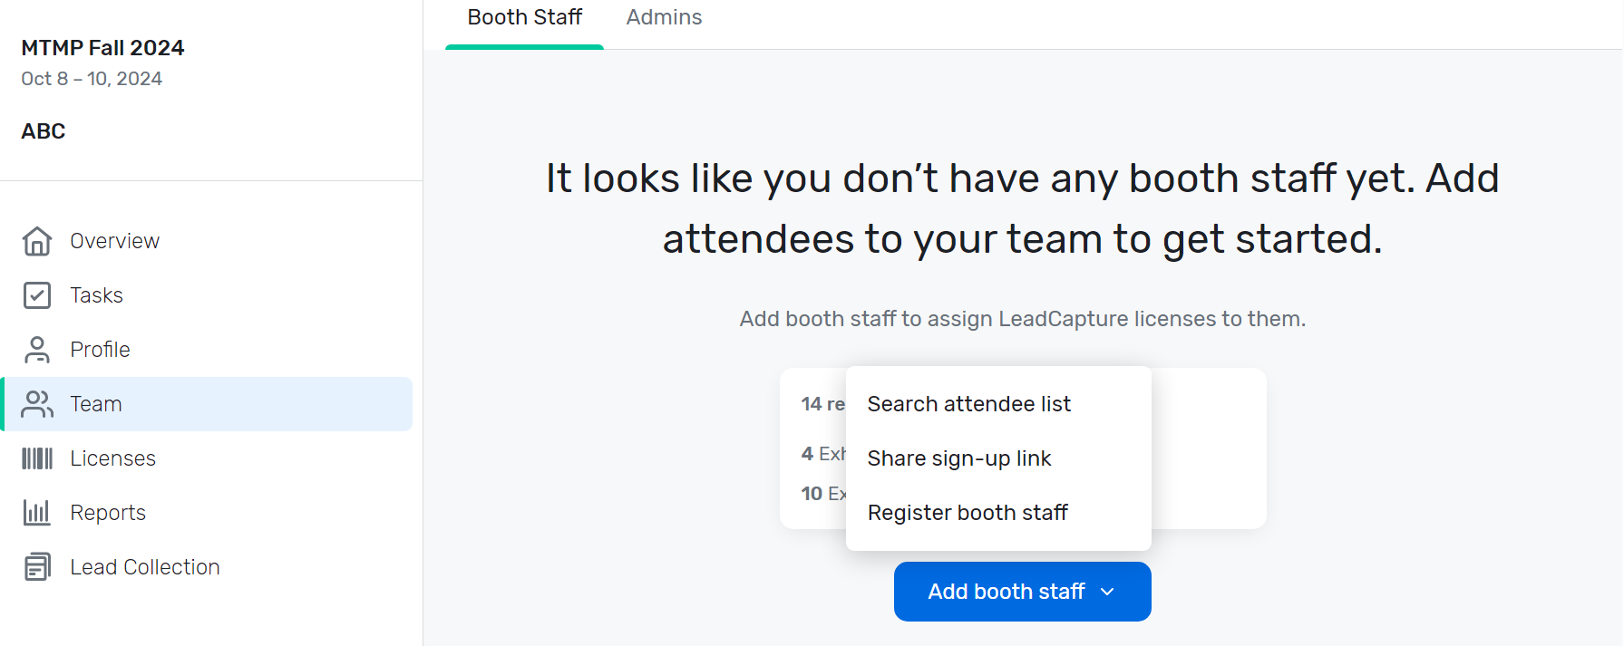
Once you click the blue button, you will see these 3 options appear. Select Register Booth Staff.

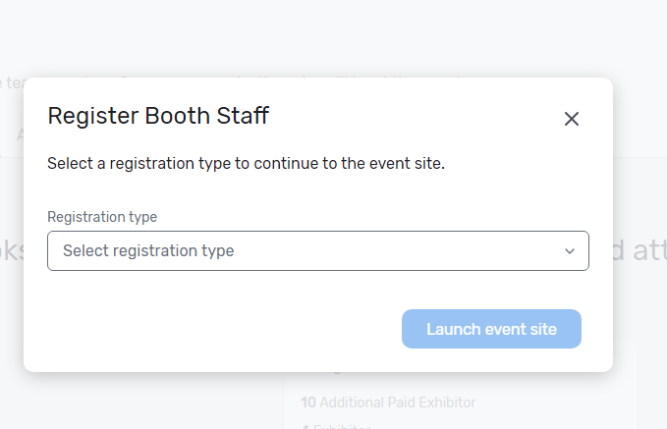
On the next page, Click Select Registration Type.

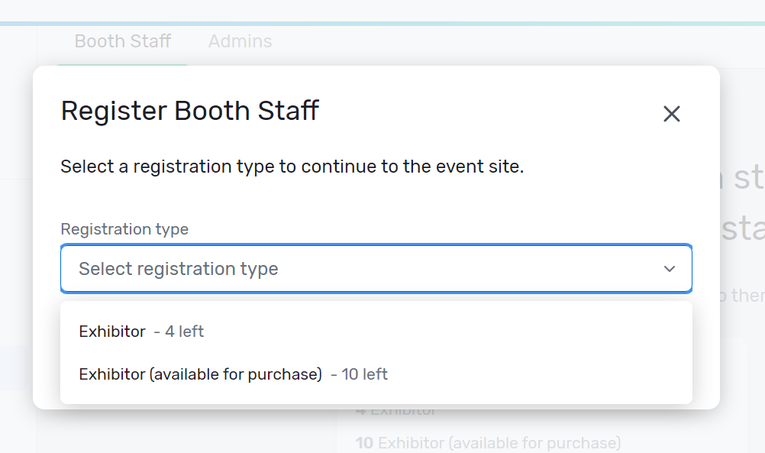
The drop-down list options are: Exhibitor- 4 left or Exhibitor (available for purchase). The Exhibitor 4 left option reflects the amount of registrations included with your contract, which is 4 staff. The Exhibitor (available for purchase) reflects the amount of registrations available for purchase. (You can purchase more than 10, we just chose that as an even number).
Select Exhibitor 4 to start registering your complimentary staff.
As you start to register your staff, your number of available Exhibitor registrations will decrease. Once you use all of your complimentary registrations if you want to add staff, you must purchase additional registrations. In this case you would Select Exhibitor (available for purchase). It will lead you to a registration page where you will register and pay for additional staff. Per your contract, your additional staff will be $1095/each. You no longer need to email or call me to add and pay for more staff.
**If you are a Sponsor without a booth:
There are no complimentary registrations included with your sponsorship. Therefore you have to purchase all of your staff registrations. If you pre-paid me directly for staff registrations, they will be shown with the Sponsor # left. Start your registration with that option. If you want to add additional staff you select the Sponsor (no booth staff reg fee). Per your contract, staff registrations with no booth are $1395/each.

If you did not pre pay for staff registrations, your option will show: 10 Sponsor (no booth staff reg fee). This reflects the available amount of staff registrations you can pay for—we just selected 10 as an even number. You will select this option and it will lead you to a registration page where you will register and pay for additional staff. Per your contract, staff registrations are $1395/each. You no longer need to email or call me to add and pay for more staff. **
**If you are a Sponsor with a Speaker:
If you have a speaker, they are counted towards your 4 booth staff. You will see one allocation for Speaker/Sponsor select this option to register your speaker only. Your 3 other staff will be registered as Sponsors.

Please refer to CVENT FAQs for help on all other items and questions, found on the Exhibit Kit Page, under CVENT.

